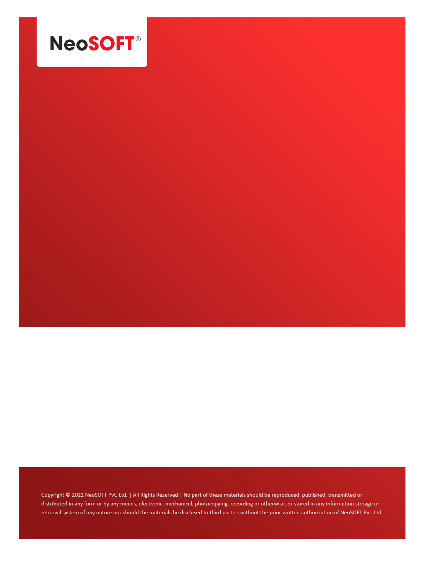`

**Eltizam MOM – Project Status meeting**

Eltizam

Client Name

NeoSOFT is a SEI-CMMI Level-5 Global IT Consulting & Software Solutions Provider

**April 26**, 2023

|  |  |
| --- | --- |
| **Meeting Date, Time, and Attendee Details** | |
| **Date** | 26th April 2023 |
| **Venue** | MS Teams |
| **Time** | 05.00 PM – 05.30 PM IST |
| **Meeting Type** | Wireframes review, Project status |
| **Internal Attendees** | * YallaReddy * Akshata Shinde * Karthik Natarajan |
| **Client Attendees** | * Karuna Pawar * Vinod Kumar |
| **Presented By** |  |
| **MOM Prepared By** | * YallaReddy |

|  |  |
| --- | --- |
| **Details of Meeting** | |
| **Sr. No.** | **Description** |
| 1 | We discussed project current status with Vinod & Karuna, expecting feedbacks on submitted wireframes from business next week as they will resume work after Eid. |
| 2 | On Friday, we will have meeting with BA team to discuss Evaluation process flow and do wireframes, required SRS preparations after that. |
| 3 | Also, discussed regarding raising Angular UI Change Request(CR) with Vinod. NeoSOFT will submit CR to Eltizam team mostly by tomorrow. |
| 4 |  |
| 5 |  |

|  |  |  |  |  |  |
| --- | --- | --- | --- | --- | --- |
| **Actionable** | | | | | |
| **Sr. No.** | **Action Item** | **Assigned to** | **Assigned Date** | **Expected Completion Date** | **Status** |
| 1 | NeoSOFT business team will submit Angular UI CR to Eltizam team. | Sean | 26th Apr | 28th Apr |  |
|  |  |  |  |  |  |
|  |  |  |  |  |  |